**Problem 1:**

Given the following logic function:



a) Find the most simplified logic expression as a product of sums

b) Find the most simplified logic expression as a sum of products

c) Implement the logic function with only 2-inputs NAND gates

d) Implement F, with MUX4 (**NO** additional logic is allowed).

e) Implement F with a decoder 4:16 and additional logic gates.

**Problem 2:**

A combinational circuit of 4 inputs (a,b,c,d) and 2 outputs (F,G) is defined by the following function and scheme:

$$G\left(a,b,c,d\right)=\sum_{4}{\left(0,1,5,7,9,10,13,15\right)+ ∆}(2,8)$$

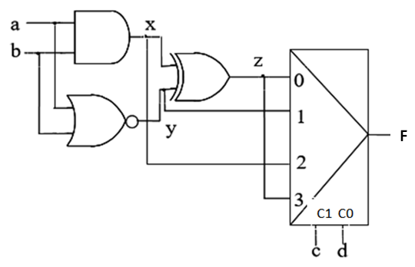

1. Write the truth table.
2. Find the most simplified logic expression of F as a sum of products
3. Find the most simplified logic expression of G as a product of sums
4. Implement G using only multiplexers with 4 data inputs and 2 select inputs.
5. Implement G using a decoder and logic gates.

**Problem 3:**

A three-input circuit, with the truth table of the figure, has been discovered to burn with the input combinations ABC=101 and 010. The cheapest solution is to add another circuit so that when the faulty combinations appear at the inputs, the new circuit replace the combination by a safe one that produces the same result in the truth table, but preventing the circuit from burning. This way, the behavior of the two combined circuits is the one represented in figure 1.

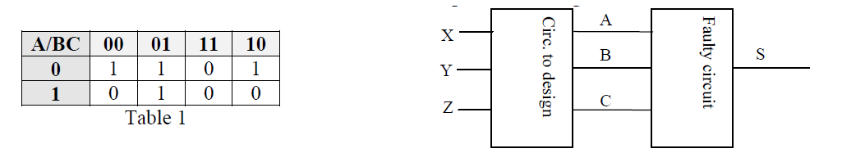

a) Obtain the truth table representing the circuit behavior, expressing functions A, B and C in terms of inputs X, Y and Z

b) Simplify the functions using the Karnaugh maps method

c) Implement the obtained functions using only AND gates

d) Implement the obtained functions using 8:1 multiplexers and inverters.

**Problem 4:**

A diamond size classification system has 3 light sensors located at 3 different levels: High (SA), Medium (SM) and Low (SB). If a diamond is big, the system activates the 3 light signals. If the diamond is medium-size, the system only activates 2 light signals (SM and SB). If the diamond is small, the system activates one signal (SB). Finally if the diamond is tiny, the system doesn’t activate any signal. The system has also a weight sensor calibrated in kilts (SP). This sensor sets to “1” if there are more than 3 kilts and resets to “0” in return. The classification conditions are the next ones:

• A big diamond (G) or a medium-size one (M) must weight 3 kilts at least, otherwise the diamond is rejected (R).

• If the diamond is small, it can’t never weight more than 3 kilts, in that case the diamond is rejected (R).

• The tiny diamonds are always rejected (R).

• The unreal conditions must be considered as impossible.

You must solve:

a) Obtain the truth table of the system.

b) Obtain the simplified logic expression of the function R as product of sums

c) Obtain the simplified logic expression of the function R as sum of products

d) Implement the function R using NAND gates.

e) Implement the function R using a multiplexer with 2 selection inputs and the minimal number of extra logic gates.

f) Implement the function R using a decoder with 4 inputs and low-level active outputs, and the minimal number of extra logic gates.